C212 Readings & Assignments: Week 1

Week 1 Readings
Complete the following reading for the week:
- Read all online lectures for Week 1.
Read following chapters from the 3ds Max 2010 Bible
- Creating and Editing Primitive Objects
- Selecting Objects and Setting Object Properties
- Transforming Objects, Pivoting, Aligning, and Snapping
- Cloning Objects and Creating Object Arrays
Practice Exercises:
Complete the following short tutorial lessons from the 3ds Max 2010 Bible:
- From the Creating and Editing Primitive Objects chapter:
  - Exploring the Platonic solids
  - Creating a pie
  - Filling a treasure chest with gems
  - Adding stairs to a clock tower building
- From the Selecting Objects and Setting Object Properties chapter:
  - Hidden toothbrushes
  - Dividing a scene into layers
- From the Transforming Objects, Pivoting, Aligning and Snapping chapter:
  - Landing a spaceship in port
  - A bee buzzing about a flower
  - Aligning a kissing couple
  - Creating a lattice for a methane molecule
- From the Cloning Objects and Creating Object Arrays chapter:
  - Cloning dinosaurs
  - Creating instanced doughnuts
  - Working with referenced apples
  - Mirroring a robot’s leg
  - Creating a path through a maze
  - Stacking a row of dominoes
  - Cloning and aligning trees on a beach
  - Building a white picket fence
  - Building a Ferris wheel
  - Using Ring Array to create a carousel
Week 1 Assignments Overview
Assignment Summary Week 1: | Due Date
Assignment 1: Autobiography | Monday, January 11, 2010
Assignment 2: Practice Exercise—Week 1. | Thursday, January 14, 2010
Assignment 3: Final Project - Composition Principles | Thursday, January 14, 2010
Assignment 4: Final Project - Blocking a 3D Room | Saturday, January 16, 2010
Remember that all assignment details can be found on the assignment pages located throughout the week. Go to those specific pages for direction on how to complete each individual assignment.

Let's Get Started
Welcome to 3D modeling and Animation I. During this course you'll learn about the basics of 3D design. Before we move on, let's see what's coming up in the next few weeks.

Weekly Coverage
The first three weeks of this course concentrate on 3D modeling. The first week covers 3D concepts and design principles. As you learn the concepts, you will begin to model simple objects by using default primitives. The second and third weeks cover 3D modeling by modifying primitives and 2D shapes, which provide you with the opportunity to add details and create complex models for a 3D scene.
The fourth week will introduce the art of "coloring" 3D models—technically known as creating and applying materials to 3D models. In the fifth week you will learn to enhance a 3D scene by putting appropriate lights, and compose a 3D scene with the help of cameras. The final week will concentrate on taking output from a 3D software application and create stills using rendering techniques.

Project
As you go through the weeks, you will complete a project among other activities. The project will involve creating a 3D room with objects, materials, lights, and cameras. Every week you will create new elements and add details to enhance the existing elements of the project as depicted in the flowchart. By the final week you will be ready with your finalized virtual 3D room.

Course Requirements
This course focuses on laying a foundation in 3D by using design and composition principles.
Remember to spend as much time as possible with 3ds Max, the software recommended for this course. Becoming familiar with 3ds Max and 3D terminology will require some time initially. As you put that extra effort, you'll realize that learning and practicing 3D is great fun.
So gear up and let's explore the amazing virtual world of 3D.

Learning Outcomes:
- Use 3D design concepts to compose a simple 3D scene.
- Demonstrate use of proper nomenclature and documentation for projects.
- Apply the design process to all stages of project development.

The Amazing World of 3D
Welcome to the first week of the course. We all live in a three-dimensional (3D) world, yet we don't all think in terms of 3 dimensions. With a little practice, reading, and discussion, you'll come to appreciate 3D concepts in ordinary objects all around you. This week we'll take the first few steps in this direction. We'll study the factors that help create realism in a 3D scene and create a simple scene using 3D primitives. Let's begin.
What is 3D design? 3D design is the art of replicating objects and scenes around us in the form of computer-generated images, in order to create a virtual world. This virtual world can be a replica of the real world or a figment of imagination. The term "virtual world" might sound alien to you; so first let's understand what virtual worlds are. A lot of 3D games contain them; take for example the game Riven, which contains the characters, sets, landscapes, and scenes that don't exist in the real world. All these images constitute a computer-generated 3D world—also called a virtual world. You'll find such realistic virtual worlds in many more games such as Quake and Myst. A 3D designer needs to visualize such virtual worlds before making an attempt to create them.
The space inside a virtual world is called the 3D space and the objects inside this 3D space are called 3D models. Suitable positioning and interaction of 3D models in the 3D space generates an illusion of the real world. 3D can represent the real world very closely—the keywords here are "'very closely" because simulating the real world accurately requires a lot of effort, time, and creative thinking. There are certain guidelines for the process of creating effective virtual worlds, which we'll look at later. For now start looking at the objects, phenomena, and processes around you more closely; developing this habit is the first step in creating virtual worlds.
Simultaneously you should learn about basic 3D concepts, starting with dimensions. In the real world every object has three dimensions—length, breadth, and height. To create 3D models you define these dimensions for the 3D model, called X, Y, and Z dimensions in 3D terminology.
After creating 3D models you need to place and orient them properly to create a 3D scene. This involves establishing a spatial relationship between the objects by using X, Y, and Z dimensions. Basic 3D concepts help establish the spatial relationship between objects. To establish a spatial relationship, let's take a look at three basic 3D concepts:
- Cartesian coordinate system
- Views
- Units of measurement

Cartesian Coordinate System
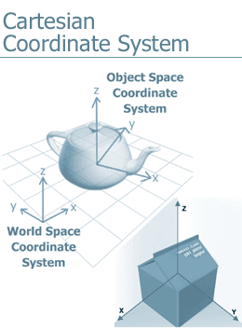
You must have studied about graphs, used in math, during your school years. These graphs use the Cartesian Coordinate System, which is also used in 3D to locate and define objects. The Cartesian Coordinate System has an origin from where every object is referenced. From the origin three lines run at right angles to each other—X, Y, and Z-axes. Any object in the 3D space can be located by measuring its distance from these axes. These distances are called X, Y, and Z coordinates of the object, and they are represented as (x,y,z). For example an object that is placed at a distance of 3 units from the X-axis, 4 units from the Y-axis, and 2 units from the Z-axis has coordinates (3,4,2).

Views
How do we estimate depth in our real world? The curvature of the lens of the eyes enables us to see things in perspective; as a result, objects located far appear smaller than the objects located near. The same effect is generated in 3D by displaying objects in the perspective view enabling us to gauge depth on the monitor screen, which is two-dimensional. On observing perspective view closely, you will find that two parallel lines seem to meet at the horizon; the same effect is observed in the real world.
In addition to the perspective view a 3D software application uses orthographic views to display objects. Two parallel lines in an orthographic view always run parallel to each other. This does not represent the real world accurately; however, it helps estimate relative sizes of the objects accurately. The name of an orthographic view is the same as the side from which you look at the object, for example if you look at an object from the front, the view is called the front view. Similarly we have the top, bottom, left, right, and back view.

Units of Measurement
Distances are measured in the real world by using the units of measurement such as meters or feet. The same units are used in 3D to define and locate 3D models, that is you can decide whether you want to measure distances in meters or feet. Specifying the units of measurement helps maintain proportions between objects when multiple people are working on a 3D project. It also helps execute an engineering project where precision is of prime importance. The units of measurement should be specified at the beginning of a project.


Introduction to Coordinate Systems
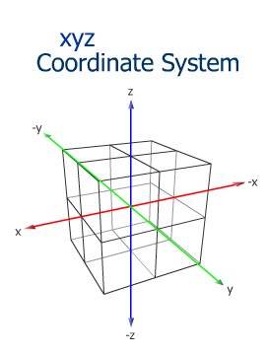
Look around and you'll find that each object around you is three-dimensional: your monitor, your PC…. The world around us is 3D. And because we are used to our 3D environment, we do not find it necessary to look at every object in terms of its height, width, and depth.
However, to give form to your imagination, a virtual world needs to be created. The first step to creating a virtual world is to understand how to position objects in that space. This virtual world is popularly known as World Space. The center of this world space is called the world origin. World Space uses the X, Y, and Z coordinate system.

X, Y, and Z Coordinate System
Any 3D object located in the world will have height, width, and depth. The X, Y, and Z-axes represent each of these attributes of the object, respectively.
The world origin is the center of intersection of these three axes. The coordinates of the world origin are (0, 0, 0) representing the X, Y, and Z dimensions, respectively. An object's location in the world space is calculated with respect to the origin. An object can be represented by the (X, Y, Z) coordinates.
Assume that an object is placed at (40, -35, 65) in World Space. This implies that the object is 40 units away form the origin of the X-axis, -35 units away from that of the Y-axis, and 65 units away from the origin of the Z-axis. In other words, (40, -35, 65) is the distance from the world origin (0, 0, 0). The figure to your right shows an object in World Space.
3ds Max can calculate the relative positions of all the objects present in World Space.
Observation Activity: Grab your space.
Place an object inside a square shaped box made of glass or cardboard. Measure the distance along each axis. Participants will record their measurement based on X, Y, and Z-axes. This exercise will give participants the basic understanding of the coordinate systems. Sketch the box on paper and represent the position of the object within it by a dot. Label the position of the object by giving its X, Y, and Z coordinates. Carry out the same exercise for different positions of the object in the glass box. Using MS Paint or a similar graphic tool create a sketch representing the dot and the box.

3D in Comparison to 2D
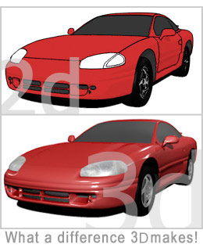
Have you compared a 2D artwork with a 3D artwork? You would have noticed that the 3D artwork looks more realistic. Not that 3D is superior to 2D in imparting realism; it's just that a first glance gives this impression. In fact a 3D artwork (a finished product or images produced from a 3D software application) can represent the real world very closely. Rendering 3D models and scenes produces these images. A good 3D artwork is the result of the creativity and honest effort of a 3D designer; the effective use of the tools and techniques available in 3D software also contributes immensely to the final look of the product.
The art of effectively using tools is learned through a lot of practice and hard work; however you should know about the factors that affect the final outcome before mastering this art. Let's learn about these factors.

The Use of Objects
Each 3D scene contains many objects, which are modeled using the tools provided by a 3D software application. You can carve, mold, and shape models the same way as a clay modeler does. A 2D software application doesn't provide such modeling tools. Well-made models replicate objects more closely than objects created in a 2D software.

The Use of 3D Space
A 3D scene provides the freedom of moving, placing, and orienting objects in 3D space. In contrast 2D objects have to be placed based on estimation. For example if you want to create two chairs of the same size and place one in the front of the other, the one at the back should look smaller than the one in the front. In 3D placing the two chairs in 3D space can easily achieve this whereas in 2D you will have to reduce the size of the chair at the back to produce the desired result.

The Use of Materials
Objects in the real world have unique surface characteristics such as shine, roughness, and transparency, which can be defined for the models that you create in 3D. This process is called creating and assigning materials to models. Once assigned proper materials, models appear similar to real-world objects. Limited tools are available in 2D software to create surface properties for objects.

The Use of Lights
You can create and place lights in 3D space as you do in the real world. When these lights fall on the models in a 3D scene, a real-world atmosphere is simulated. This means you can also create a mood in a 3D scene by using lights. In 2D software sophisticated lights are not present; each effect has to be painted in a scene.

The Use of Cameras
A 3D software application provides cameras to view a 3D scene. The camera acts like the eye of the viewer. Using cameras in 3D is similar to taking a photograph of a scene in the real world; the camera can be placed at an appropriate place to obtain the output immediately. A 3D software application calculates all the angles in a scene making it easier to experiment and compose a 3D scene quickly; in a 2D software application for each camera angle a new image needs to be created.
Some or all of these factors contribute in making a 3D image appear realistic. If you look closely at a 3D image, you can deduce the factors responsible for creating the desired effect in a 3D scene.

Difference Between 2D and 3D
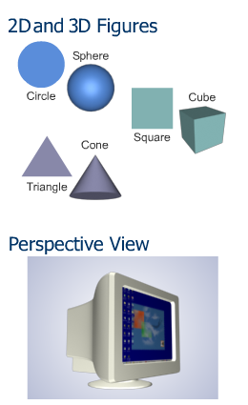
Let's try to identify the difference between 2D and 3D with the help of an example. Consider a painter and a sculptor at work. A painter uses paints and brushes to draw on canvas. This painting is on a 2D plane. There is no third dimension on the surface of the canvas.
Unlike the painter, the sculptor works on three dimensions. The sculptor is able to go around the sculpture and feel it evolve in all the three dimensions. The painter brings out the effect of textures and lights with the judicious use of colors whereas the sculptor uses some tools to skillfully carve textures on the model.
The difference between 2D and 3D software can be compared to the difference in the work done by the painter and the sculptor. 2D software recognizes an object with the help of the X and Y axes whereas 3D software uses the X, Y, and Z axes.
2D software provides light effects that can work only on the X and Y planes whereas 3D software provides light effects and cameras that can work along the Z- axis as well. As a result images developed in 3D software are closer to real life. However, we always need to consider that the artist behind the tool is who creates a good piece of art. This means that 2D and 3D artists need to adhere to the very basic foundation of art and design when developing their work. Let us take a look at how these basics of design that you have learned in previous courses can be applied to 3D design.

Composition Principles
Creating virtual worlds not only involves mastering the tools and techniques of 3D software but also understanding the composition principles governing the process as well. Before we look at composition principles, let's look at some of the guidelines for developing a 3D scene.

Making Sketches of the Scene
The creation of a 3D scene begins with visualizing the scene i.e. planning what you want to show in the scene. The best way to proceed is to make a sketch of the 3D scene and the models in the scene. You don't need to be an excellent artist to draw these sketches; rough sketches more or less solve the purpose. With the sketches the world in the imagination begins to take a form making it clearer what to display in a 3D scene.

Dividing the Scene into Layers
Once the drawings have been finalized, you should concentrate on dividing the complete scene into depth layers. Normally a scene is composed of three depth layers: foreground, middle ground, and background; the foreground layer is the nearest to the viewer, and the background layer is the farthest from the viewer. The middle ground layer sits in the middle of these two layers. You should identify which objects in the scene will be a part of which layer. For example consider that you are creating a 3D scene that will display a spring. The sky belongs to the background, the mountain from which the spring will originate belongs to the middle ground, and the spring itself belongs to the foreground layer of the scene.
Dividing a 3D scene into layers offers two advantages:
- You have the freedom to modify and refine individual elements of the 3D scene without affecting the surrounding elements that are part of a separate layer.
- When working as a team, individual layers can be developed, refined, and rendered separately. This speeds up the production cycle.

Creating Simple Solutions
3D designing is all about making the audience believe that what it is viewing is true. At times replicating the effects of the real world is time-consuming. In these situations simple solutions to the problems should be found. For example to create a car tire, you can create each groove of the tire and spend hours completing the tire, or you can create a 2D bitmap for the texture of the tire and map this bitmap on the tube primitive. If you follow this approach, your focus will be on how to create the texture of a tire rather modeling the tire itself, making the task simpler.

Advantages of a Good Composition
Now that you have gone through some guidelines for creating 3D scenes, let's talk about following composition principles. An obvious question here can be
"The audience doesn't know about these principles, so why should I follow them?" The answer lies in the impact a good composition creates on the audience. Let's quickly look at the advantages of creating a good composition.
A good composition:
- Sustains the interest of the audience.
- Binds a scene together by organizing the structure of the scene.
- Creates mood for the scene.
- Helps to convey your message to the audience.
All these elements come together to make the composition by the application of the principles of design. Applying the software tools effectively will make a difference on the strength of the concept, but applying the tools on an artistic manner will have an even stronger impact on the viewer. Let’s see how you can apply these principles of design to a good 3D scene.

Balance
The distribution of visual weight in a work of art is called balance. It can be either asymmetrical or symmetrical. When elements on both sides of a central vertical line appear to be about equal in color, weight, shape, and value, the design is in symmetrical balance whereas when the elements on either side of the vertical line are different with respect to the above-mentioned properties, the design is in asymmetrical balance.

Movement
Visual movement is created in a scene when a viewer's eye is directed to the focal areas of the scene. Shapes, edges, lines, and color within an artwork can direct this movement.

Rhythm
Repetitive visual movement of elements is called rhythm. Shapes, lines, textures, values, colors, forms, and spaces create rhythm. You should use rhythm with variety; this helps make an artwork interesting.

Emphasis
Emphasis refers to effort to create focus or dominance in an artwork. Artists can emphasize color, shape, value, or other art elements. Visual emphasis on a focal area can be achieved by contrasting the strongest light and dark values in a dominant location in a painting.

Contrast
Contrast refers to differences in values, textures, shapes, colors, and other elements. Contrast creates visual excitement and perks up viewers' interest in an artwork.

Unity
Visual unity, an important aspect of well-designed art, is achieved when all the elements in a work of art look as though they belong together. Planned by an artist in advance, visual unity refers to cohesion, the quality of an artwork appearing pulled together and finished.

Scene Development
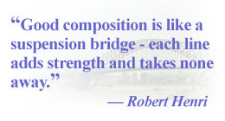
In addition to applying the principles of design, a good 3D scene takes into consideration other concepts that affect the viewer’s perception of the scene. Scenes are integral to storyboards and should be built to captivate the viewer's attention. One look at the scene should give the message that you as an artist want to convey to the viewer. A good composition is the best way of portraying the imagery in your mind.
Scene development involves composing a scene based on its theme. At times a scene might not convey the desired message. This can happen if the designer has missed any factors essential for a good composition. Composition is an art that can be mastered with experience. A good composition follows the principles of composition.

Principles of Composition
You can create a good composition by following these principles:
- Scene division: You can place objects in any of the three areas of a scene: background, foreground, and middle ground.
- Background: The region that is at a distance from the viewer's perspective is called the background. The objects placed in the background tend to appear smaller than their actual size. The background on a scene can range from a city on the far distance, to a table edge on a close-up of an object on the table.
- Foreground: The region that is closest to the viewer's perspective is called the foreground. When objects of the same size are placed in these 3 regions, the object in the foreground will appear larger and clearer than the others to the viewer.
- Middle ground: The region in between the foreground and the background is the middle ground. Assume that objects of the same size are placed in these three regions. An object in the middle ground will appear to be smaller than an object of the same size in the foreground and larger than another object of the same size in the background.
The mapping of objects to a region will depend on the theme of a scene. Objects can be placed in any of these three regions based on their distance from the viewer or the camera.
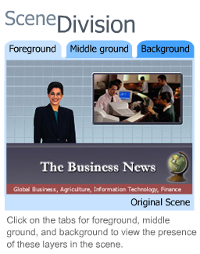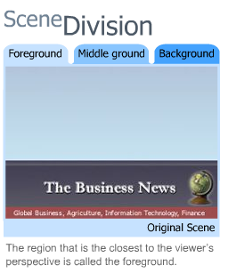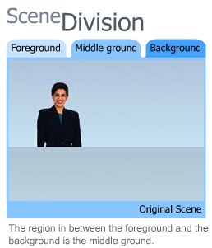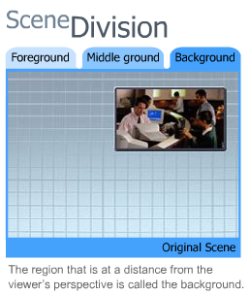

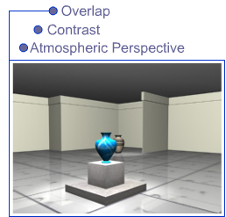
- Illusion of depth: The techniques mentioned below help in creating an illusion of depth.
  - Overlap: Overlapping is a technique of placing an object in a way that it hides some parts of the object behind it. This is one way of showing depth in a scene. For example, a character behind the bushes can show overlapping of the leaves covering the character’s face.
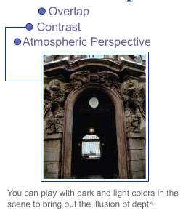
  - Contrast: You can play with dark and light colors in a scene to create an illusion of depth. Dark colored objects and cool colors are useful to show the distance of the scene from the viewer. Similarly using warm colors and light colored objects will make the scene appear to move towards the viewer. We will deal with colors and lighting in a separate topic in the following section.
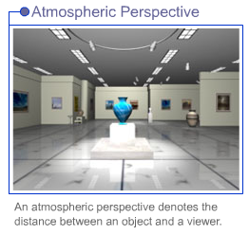
  - Atmospheric perspective: An atmospheric perspective denotes the distance between an object and a viewer. Remember that the farther an object is from the viewer, the greater is the distance traveled by light to reach the viewer's eye. An object close to the viewer will be clear to view. Such a perspective gives an illusion of depth. This is often represented in the 3D world with fog that gets more dense as it recedes from the foreground layer.

Center of Interest: On a daytime 3D scene, you can use of dull colors for the background and warm colors in the region (middle ground or foreground) where an object is placed can help the viewer focus on the center of interest. Every scene should have a central focus based on its theme.

Viewer's Perspective: A viewer's perspective plays an important role in scene composition. After creating a center of interest the next step is to portray the scene in a manner that the attention is focused on the desired area. You can do so by changing the camera angle. A change in the camera angle will automatically lead to a change in the viewer's perspective. For example, the view from an ant on the ground would be most likely facing upwards, and showing objects on a larger scale, while the view of a giant would be looking down with the scene elements looking much smaller. We will learn more about camera angles in the next section.
In the last section we discussed about the viewer's perspective. Changing camera angles helps us show the viewer's perspective. Let's take a look at the types of camera angles and shots that can be used.
Camera Angles

The camera angles used to shoot a scene can often portray the mood of the scene. At this juncture it is important for us to understand some of the more common types of shots and camera angles, given that you will be working with cameras on a 3D scene.

- Types of Shots
  - Close shot: When the subject fills nearly the entire scene with little space left for the background, it is called a Close shot. Close shots are generally preferred to depict the emotions and expressions of a character. In an environment scene, you can have a close shot by framing only one object of the scene very close. For example, in a living room scene, a coffee mug on the table that frames only the mug could be a close shot.
  - Medium shot: This shot strikes a balance between a character and the rest of the scene. Medium shots are preferred to show the body language of characters. Following the example above, a medium shot could be the table with the coffee mug sitting on it.
  - Long shot: A long shot is best used to capture a vast area or locale in a small scene. In such shots the subject is not clearly visible as compared to the surroundings. Following the example above, a long shot could be the view of all the living room.
- Types of Angles
  - Eye-level angle: An eye-level angle shot is the shot focused from the subject's eye level.
  - Low angle: A low angle shot is used to make the subject appear more dominant and large. Visualize the camera on the ground looking up, as on our ant-view example before.
  - High angle: Unlike the low angle shot the high angle shot is used to make the subject appear submissive. An example of this will be the shot of a small child looking up to the parent with teary eyes.

Using appropriate camera angles and the principles of composition can help create a good strong 3D scene. You can set the mood of a scene by the use of colors and lights. On the next section, we will see how perspective also comes into place to make a strong scene composition.

Two-Point and Three-Point Perspectives
Often you might have peeped out of a train moving away from a station. The people on the station start looking shorter and hazier as the distance of the train from the station increases. The long stretch of the station before you seems to fade away. At the same time a friend who is at the station to see you off will see things differently. From her viewpoint, large compartments of the train will soon look like tiny matchboxes as the train moves away from her.
As an artist you'll be able to bring out such effects in your art. Your perception of the station from a moving train will be different from the perception of your friend standing on the platform. Perception is the point of view of an observer. Let's look at some terms associated with perception.
- Perspective: Perspective is the art of representing objects in order to give them depth and a 3D effect.
- Ground plane: This is the plane on which an observer stands.
- Horizon line: The imaginary line drawn parallel to the ground plane at the observer's eye level.
- Vanishing point: The imaginary lines of perspective originating from objects in a scene appear to converge at a point on the horizon line. This point is referred to as the vanishing point.
Based on the number of vanishing points, there are three types of perspectives as shown in the graphic.
After reviewing the design and composition principles, we can get started with learning the interface of the 3D software that we will use to create our 3D scene. Remember that as artists, we want to create a strong scene, not just show that we can use the tools within the software.
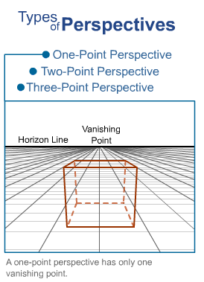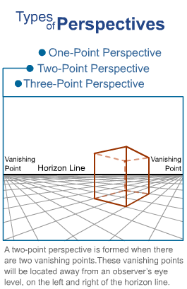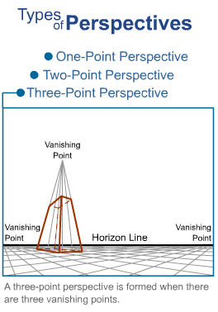

Creating a Simple 3D Scene
We have come to a crucial point this week. The theory that we learned during this week has to be complemented with some practical work; let's start creating models in 3D.

Types of Coordinate Systems
3ds Max provides seven types of coordinate systems known as Reference Coordinate System. These are available in the drop-down list of Reference Coordinate System on the main toolbar of 3ds Max.
World Space and Object Space
To understand the concepts of World Space and Object Space, consider your present sitting position. Your workstation can be considered the Object Space and your home the World Space. Most scenes created would have the Object Space complementing the World Space. Let's take another example of World Space versus Object Space.

A small nursery contains a few potted plants. The nursery can be thought of as World Space. The positions of the plants are fixed with respect to the space in the nursery. This space would define a pot's position, size, and placement in the nursery. But there is a plant that needs more manure. When manure is added, it only affects a particular potted plant therefore modifying its Object Space. The others remain unaffected.

3ds Max follows a world coordinate system to position objects in a scene. This World Space defines an object's position, scale, and rotation in space. The axis displayed in the lower-left corner of the viewport defines the World Space coordinates.

On the contrary the coordinate system in an Object Space is specific to an object. Various elements such as vertices, modifiers, map coordinates, and materials are defined in Object Space. Object Space uses the local coordinate system to modify its parameter.

Object Dataflow
Assume that a friend seeks your help to create a new scene in 3ds Max. You can spare only three hours for him, as you have some prior commitments set for the day. You decide to help him. However, before you start it would be important to determine the function of each of the models required for the scene. After the functions are determined, you may want to use a collection of objects provided by 3ds Max to build your model. It will be easier to create new scenes by modifying these base objects.
The order in which the software evaluates a scene for Object Dataflow is as follows:

- Master Object: Defines the parameters and type of the initial object created in a scene. This is usually provided by the software.
- Modifiers: Associates modifiers to an object, if any.
- Transforms: Tracks position, rotation, and scaling of an object in the scene.
- Space Warps: Distorts all the objects in World Space.
- Object: Gives a unique name to the object and displays its properties for the final object created. Let's discuss each in detail.

Master Object
The Master Object required for creating an hourglass can be a cylinder. It defines the object type, parameter, and orientation. Master object is displayed in the scene only after all the steps of object creation are completed. Master object provides the following information:
- Object Type: The information regarding the type of object is stored in Master object. Master objects can be the built in base objects, such as primitives and splines.
- Object Parameters: The height, width, length, segments, or radius of an object defines the parameters of an object.
- Object Orientation: This affects the placement of an object with respect to World Space. Master object stores the pivot point and orientation of an object with respect to the local coordinates. In other words the information regarding Object Space is contained in Master object.

Object type, parameters, and orientation.
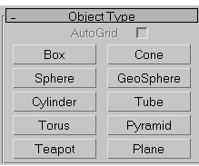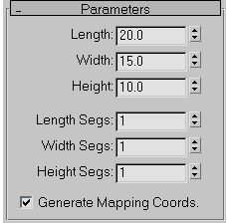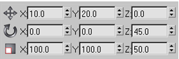

Modifiers
You can relate modifiers to play dough you used back in school. Do you remember creating and then modifying your models using play dough? Modifying tools are usually applied to change the shape of an object. Modifiers are applied with respect to Object Space. To create an hourglass, we can start by creating a cylinder and applying a modifier to it.

Transforms
After an hourglass is created, you may want to change its size, location, or rotation. The change applied to an object is defined as a transform.

The transform parameters are defined by:
- Position: Movement of an object depends on the chosen coordinate system on its local pivot point.
- Rotation: Rotation of an object depends on the chosen coordinate system on its local pivot point.
- Scale: Scaling does not affect the base parameters of an object. An object can be scaled either by applying a uniform scale or a non-uniform scale. There is another option available that gives a squash effect by scaling along an axis and giving an opposite effect on other axis.

Refer to the graphic on the right to see the Position, Rotation, and Scale Transform applied to an object.
Space Warps

Space warps affects all objects with respect to World Space. You can consider applying Space warp to show a windy day or to distort all objects in your scene. To apply Space warp, you need to bind all objects to it. Note: Remember that a modifier is used to affect the structure of a specific object, but a Space Warp is used to affect more than one object in World Space.

Object
In our example the hourglass is the final object while the cylinder is the master object. An hourglass object stores information regarding its color, dimensions, material that defines its texture, its capacity to cast shadows, and the object's name.

Creating Primitives
The basic building blocks in 3D are called primitives. Some examples of primitives are Box, Sphere, Cone, and Cylinder. These default objects can be used to start building a scene. Primitives are located in the Geometry category of the Create panel on the right side of 3ds Max interface. Creating primitives is very easy. Select the respective primitive, and click and drag in one of the viewports. You might have to click and drag several times before a complete object is created.

Primitives should be named appropriately. You can formulate your naming conventions and use them consistently in a project. The number of objects increases exponentially with the detailing of a scene. The proper naming of objects helps select and locate objects in a complex scene. In addition when a team works on a project, naming conventions speed up the work by helping team members identify objects by their assigned names and not the default names. For example the name "TableTop" is preferable to "Box01."

Selecting Objects
The tools let you select multiple objects and group them. Grouping objects is particularly helpful when you create a model that consists of many objects; when grouped, the objects can be moved, rotated, and scaled together.

Transforming Objects
After selecting an object you move the object to place it at an appropriate place in a scene - known as transforming an object. Other transform operations that can be performed on an object are rotate and scale. Objects can be transformed in X, Y, and Z dimensions. Note that transformation does not change the parameters of an object. For example if you scale a sphere of radius 4 units to 50% of its original size, the radius length will still be 4 units. By scaling you have simply transformed the sphere to a different state in 3D space. To reduce the radius of the sphere you will have to change the radius property of the sphere.

Cloning Objects
While creating 3D models it's a good idea to reuse already created objects; cloning objects lets you achieve this. For example while creating a table you can create a cylinder and clone it to create the other three legs. There are many methods to clone objects in 3D; the shift-clone method is easy to use. In this method you press the Shift key and drag the object to a new location. The created clone can be a copy, instance, or reference of the original object. Let's look at each type of clone.
- Copy: A copy is an exact duplicate of the original object but has no connection with the original object i.e. the new object can be modified independently of the original object.
- Instance: An instance is connected with the original object; so if any instance of an object is modified, the original object is also modified and vice versa. Instances are used to make similar-looking objects in a scene that change shape and size simultaneously. For example the legs of a table should be modified equally. Therefore the legs should be instances of each other.
- Reference: A reference is similar to an instance; the only difference is that if a reference is modified by applying a new modifier, the original object is not modified. However on modifying the original object, the reference is also modified.

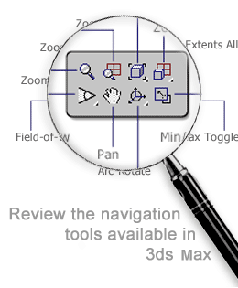
Navigation Tools
At times the objects are lost in the 3D space. To locate these objects in the 3D space, you can use navigation tools. These tools are located at the bottom-right corner of the 3ds Max interface. These tools can be used to zoom in or zoom out of a viewport or multiple viewports simultaneously.
Rendering 3D Scenes
Once a 3D scene is created you render it to generate an image of the selected viewport. At the time of rendering, the software calculates all the parameters and effects in the scene and produces an image of the 3D scene.

Applying 3D Modeling Techniques

Types of Primitives
Observe the objects around you and try to analyze how they were created. You'll realize that each object is made of some smaller pieces. Let's take an example of a bookshelf made of wood. Think of how a carpenter constructs it. He sees a design and then tries to analyze how many pieces of wood are required, calculates the distance between each shelf, determines the shape of the shelf, and so on. A carpenter starts with some wooden boards and cuts them into pieces to be later joined together to create the final model.
Similarly in 3ds Max there are basic building blocks called primitives. These are basic geometric objects available in the software. Some examples of primitives are Box, Sphere, Cone, and Cylinder. These default objects can be used to start building a scene.
There are two types of primitives, Standard and Extended. Standard primitives are basic objects provided by 3ds Max that are used to create any object, whether it is simple or complex, and Extended primitives are complex primitives.
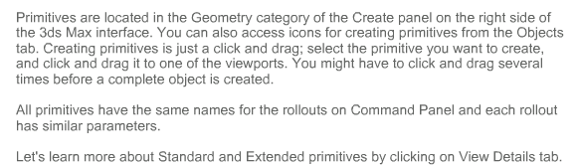
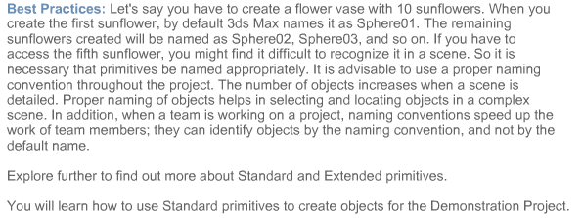
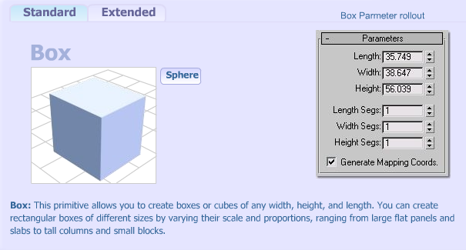
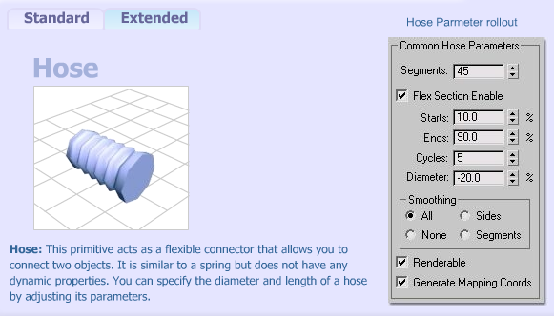

Summary
This week, you have explored the interface of your 3d software. You have also seen how the design principles can be applied to 3d scenes, and the importance of Scene Development.
You will now start the development of your final scene and learn what a blocking is and why we use it in the industry to create a reference point.
Next week, you’ll continue learning more about modeling with splines, or as you might know them now, curves. These can be very helpful in different situations that you will learn about.
Proceed to complete the exercises on the Assignments section to put into practice the concepts learned in this week’s lectures and Reading Assignments.

Assignment 1: Autobiography
The beginning of a new course brings with it many emotions that can range from anxiety to enthusiasm, and excitement. Depending on your personal traits, one or more of such feelings would be intensified. Let's share these feelings with the class. What inspired you to take a course like 3D Modeling and Animation? What are your expectations of the course? What are your exact feelings right now?
By Monday, January 11, 2010, post your autobiography to this Discussion Area. Include your responses to the above questions in your autobiography. Also discuss your areas of interests.
By the end of the week, provide feedback to at least two other classmates on their feelings about this course and their introductions.
Assignment Examples: Course facilitator's autobiography provided as an example to follow.
Assignment 1 Grading Criteria: | Maximum Points
Autobiography should contain the following information:  - Areas of interest.  - Expectations from the course.  - Answers to questions above | 6
Participation in class discussions. | 2
Total: | 8
For assistance with any problems you may have when completing this assignment—OR—to offer your assistance to classmates, please use the Problems and Solutions Discussion area located through the left side navigation link.
W1A1
Hi Everyone,
I wanted to start off this thread by giving you a little info about myself…
Let's see...my husband and I just started a small studio here in Atlanta doing asset production and eventually motion capture. Small steps now so we can keep moving forward. Also working full-time and teaching here.
I just completed freelance work for a mobile game company using motion capture. This presented a new set of challenges that I am not accustomed to, but was fun none the less.
I am married to a gamer and animator as well and we have lots of fun talking about and playing games. We both have a Masters in Dramatic Media which entailed lots of theater, audio, video, animation and game design. The other half’s emphasis was in Character Development and mine was in Facial Animation and Motion Capture.
I enjoy all types of games and especially love FPS (First Person Shooters) and RPG (Role Playing Games). My favorites are Final Fantasy and Zelda, and of course GOD OF WAR!!!!!!!. On the FPS part, I am currently playing Call of Duty 4 and Battlefield: Bad Company on XBOX 360 online.
I look forward to hearing about the games you all play and having a great term.
Assignment 2: Practice Exercise
This week, you're seeing how to move primitives around on your scene and how to get started with 3d modeling. Complete the exercises listed on the Reading and Assignments section.
By Thursday, January 14, 2010, write a note on the areas listed below and post it to the Discussion Area along with the jpgs of all the exercises outcomes. Also by Thursday, January 14, 2010, save your 3ds Max files for each of the exercises to the W1: Assignment 2 Dropbox.
Respond to the following self-evaluation areas:
- Which lesson do you find more valuable?
- Which problems did you encounter through the process and how you fixed the problem?
- List and provide an explanation of at least two concepts that you learned this week.
- Explain how you can apply the concepts included on this exercise to your final project (see Assignment 3 this week for more details on the final assignment).
By the end of the week, respond to at least two other student’s postings. Comment on their achievements and their findings included on their note. Post your responses to the Discussion Area.
Assignment 2 Grading Criteria | Maximum Points
Successfully completed all practice exercises listed in the Reading and Assignments section. | 4
Included notes on the learning experience. | 4
Participated in class discussions. | 4
Total: | 12
For assistance with any problems you may have when completing this assignment—OR—to offer your assistance to classmates, please use the Problems and Solutions Discussion area located through the left side navigation link.

Assignment 3: Composition Principles
Think of situations in which you can use the composition principles that you have studied in the online lectures and assigned readings.
Then, draw at least three sketches of the interiors of the room that you have visualized. Limit the situations to a room interior, or a visually interesting area of the room. This will become your final project on this class. Think of applying design principles to your composition, by achieving a focal point with light, or perhaps isolation, or perhaps achieving repetition within a bookshelf or a dinner table with plates and silverware on it.
The room could contain simple objects, such as tables, chairs, armoire, cabinets, beds, etc. There is no restriction on the type of room that you will create. For example, you can draw a living room, bedroom, show room, or even an office cubicle. You will use these sketches in the final project. For each drawing sample, explain the composition principles that you have used to compose the scene.
Refer to the textbook’s color inserts to get ideas of indoors models. Remember that you can decide to focus on one visually appealing area of the room or model the entire room.
By Thursday, January 14, 2010, scan your sketches and save them as LastName_W1_A3.jpg. Post your sketches along with note on how you see the composition principles applied to each one of them. Posts your sketches and your jpgs to this Discussion Area.
Before the end of the week, review the sketches made by any two students and comment on the composition principles that they have used. Post all comments to this Discussion Area.
Portfolio Alert!
This project may be required for your portfolio reviews. Make multiple backups and save them as part of your portfolio review requirements.
Assignment 3 Grading Criteria: | Maximum Points
Followed composition principles or composition styles discussed in the lectures. | 4
Sketches look clean and clear, with detail that defines each element on the sketch. | 4
Added a note on each sketch, using the terminology that is referenced in the lectures and reading assignments. | 4
Posted constructive comments about the sketches posted by other students. | 4
Total: | 16
For assistance with any problems you may have when completing this assignment—OR—to offer your assistance to classmates, please use the Problems and Solutions Discussion area located through the left side navigation link.
W1A3
Please submit your 3 images here. Please submit them as jpgs, as a word document or a pdf containing all of the images.

Assignment 4: Final Project - Blocking a 3D Room
A blocking is known in the animation industry as a gestural draft of what a scene or a model will look like. The term is applied to modeling, as well as animation and special effects.
Choose a sketch from the sketches that you have made in the previous assignment and create a blocking of your 3d room. This room will become your final project as you go through this course. At the end of each week, you will apply what you learned that week to your final project.
Start by creating the walls, floor and ceiling with 3D primitives, such as planes or cubes. Then, proceed to block the placement of the various components of the room (use Standard Primitives, like cylinders, planes, boxes, etc., or Extended Primitives). For example, you can make a table by placing a box on the top of four cylinders. If you want the edges to be rounded, use a chamfer box instead. Be careful that the primitives are not unnecessarily overlapping each other in the different scene components that you create.
Similarly there should be no gaps left between the primitives (not floating on the middle of the air). Use Move, Scale and Rotation tools to place and scale the primitives. You will create and or modify the elements in your scene as you go along in the course.
Rename ALL the primitives to significant names (on the Modify Tab). This means that if you created a table from a box, rename the Box01 object to Table. If you used a box for the table top and created cylinders for the legs, rename the legs from Cylinder01, 02, 03, 04 to TableLeg01, TableLeg02, etc., and the table top as TableTop instad of Box01. Remember to use Grouping when an element consists of several parts.
Save your 3ds Max file as LastName_W1_A4.max. Render your file and save your jpg as LastName_W1_A4.jpg.
By Saturday, January 16, 2010 post the 3DS Max file to the W1: Assignment 4 Dropbox. Also by Saturday, January 16, 2010, post a self critique using the guidelines below along with a rendered .jpg file of your scene (from the Perspective camera). All discussions should be posted to this Discussion Thread.
Use the following guidelines for your self critique:
- Did you achieve your modeling and design goals?
- Which areas of the project are you satisfied with?
- Which areas of the project do you believe you could improve?
- Which difficulties did you find during the modeling process? How did you solve these difficulties (which solutions worked for you)?

Before the end of the week, critique the work posted by at east two other classmates. Discuss all of the following:
- Which areas were most successful? Discuss the application of this week’s concepts to the work.
- Which areas could use improvements?
- Provide ideas or tips on how to improve these areas based on what you have learned this week.

Assignment 4 Grading Criteria: | Maximum Points
Student included all elements of the proposed scene. | 5
Placement, rotation, and proportions are accurate, according to planned sketch(es). | 10
Instructions were followed with output delivered in the specified file formats and required naming conventions. | 4
Student responded thoughtfully to self-critique questions. | 5
Student critiqued at least two other students work based on the critique guidelines. | 4
Total: | 28
For assistance with any problems you may have when completing this assignment—OR—to offer your assistance to classmates, please use the Problems and Solutions Discussion area located through the left side navigation link.

W1A4
Please post your blocked out room. Please pay attention to the naming convention for BOTH the max and jpg files required. Please submit here and NOT to the Doc Sharing section.

